Experiment II — Advanced IaC Techniques

Submitted by-Shreyash Shivhare

Sap ID-500122740

Roll no.-R2142231555
Batch-2 (DevOps)

Field | Detail
Course outcome | CO5
Marks | 5 marks (part of the 20 marks allotted to CO5)
Date of performance
Marks awarded

Aim
To explore advanced Infrastructure as Code capabilities by provisioning multiple interdependent virtual machines and by configuring network settings and security groups entirely through code.

Objectives
- To model a multi-tier network topology — VPC, subnets, gateway and routing — as code.
- To provision several virtual machines whose creation order is governed by dependencies.
- To express least-privilege firewall rules using security groups that reference one another.
- To refactor a flat configuration into reusable modules with defined inputs and outputs.
- To validate the design with both positive and negative connectivity tests.

Requirements
Hardware Software
- Terraform CLI 1.6 or later
- AWS CLI v2, Git, Visual Studio Code
- Graphviz, for rendering the dependency graph produced by terraform graph
- An SSH client

Accounts and access
- The AWS account and IAM user from Experiment I, with permissions for EC2 and VPC
- An EC2 key pair created in the working region, for SSH access to the web tier

Theory
  - The Resource Dependency Graph
Terraform does not provision resources in the exact order they are written in the configuration file. Instead, it parses the configuration and builds a Directed Acyclic Graph (DAG) to determine the correct sequence of operations. If one resource references the attribute of another (an implicit dependency), Terraform guarantees that the prerequisite resource is created first. If a dependency cannot be inferred through references, the author must declare it manually using the depends_on meta-argument (an explicit dependency). This graph model allows Terraform to safely provision independent resources in parallel, drastically reducing deployment time.
  - Meta-Arguments: count and for_each
Infrastructure often requires multiple similar resources, such as a cluster of web servers. Rather than duplicating resource blocks, Terraform provides meta-arguments to handle iteration. The count meta-argument accepts a whole number and provisions that many identical copies of a resource, accessible via an index (e.g., count.index). The for_each meta-argument accepts a map or a set of strings, provisioning a distinct resource for each item. While count is simpler, for_each is preferred for infrastructure that may scale up or down dynamically, as it avoids the destructive shifting of array indexes.

  - Modules
A module is a container for multiple interrelated resources that are used together. Just as functions allow developers to reuse code in traditional software engineering, modules allow infrastructure engineers to package a complex topology—such as an entire VPC or a compute cluster—into a single, reusable component. Every Terraform configuration has at least one module, known as the root module. When the root module calls a child module, it passes arguments into the child's input variables and consumes the child's exported outputs.
  - Virtual Private Cloud Fundamentals
A Virtual Private Cloud (VPC) is a logically isolated section of the AWS cloud where cloud resources are launched in a custom-defined virtual network. A VPC spans an entire region and is carved into smaller chunks called subnets, which reside in specific Availability Zones. A public subnet is one whose traffic is routed to an Internet Gateway, allowing its instances to communicate with the outside world. A private subnet has no direct route to the internet, providing a secure boundary for backend resources like databases that must remain completely isolated from public access.
  - Security Groups and Least Privilege
Security groups act as virtual, stateful firewalls operating at the network interface level to control inbound (ingress) and outbound (egress) traffic. They operate on a default-deny paradigm; all inbound traffic is blocked unless an explicit "allow" rule is authored. The principle of least privilege dictates that an entity should only be granted the exact permissions required to perform its function. In IaC, this is achieved by scoping security group rules as narrowly as possible—for instance, allowing database traffic on port 3306 exclusively from the security group ID of the web tier, rather than opening the port to a broad IP range.

Procedure
Step 1 — Design the topology on paper
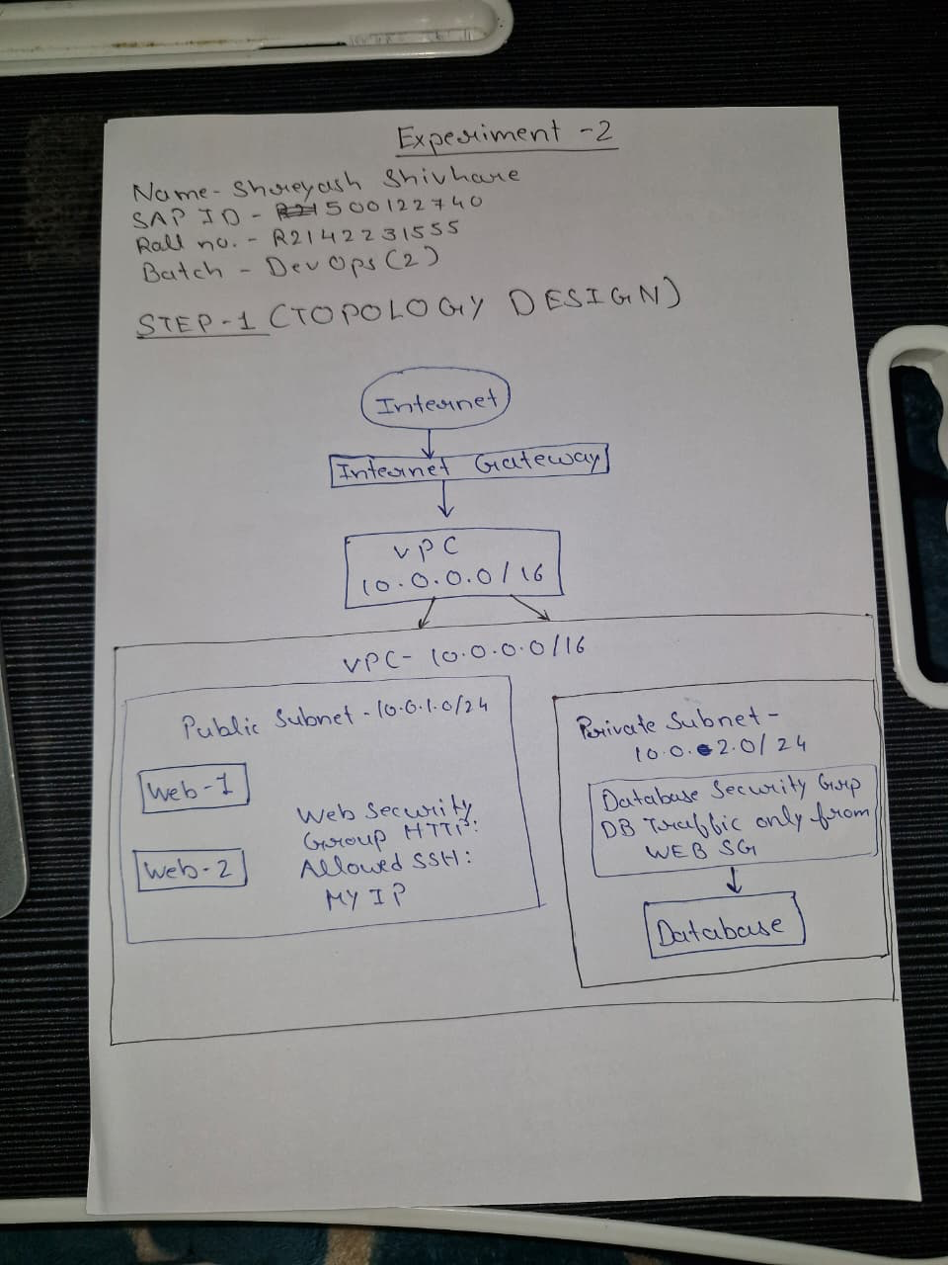

Step 2 — Create the module directory structure
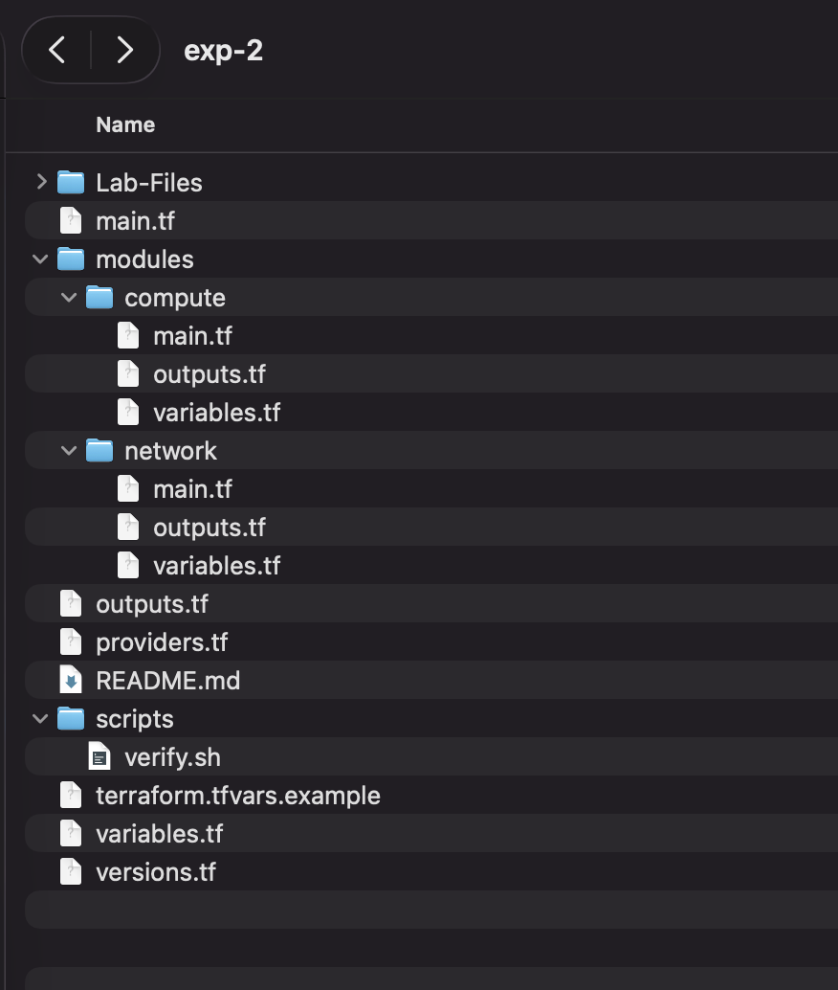
Step 3 — Provision the VPC and the subnets
from {modules/network/main.tf}
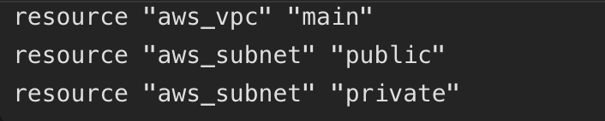
Step 4 — Attach the internet gateway and configure routing
from {modules/network/main.tf}
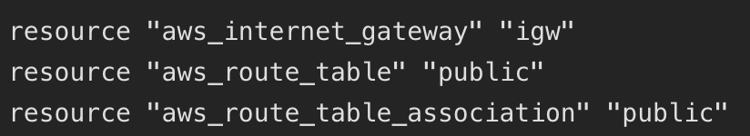

Step 5 — Author the security groups
from {modules/network/main.tf}
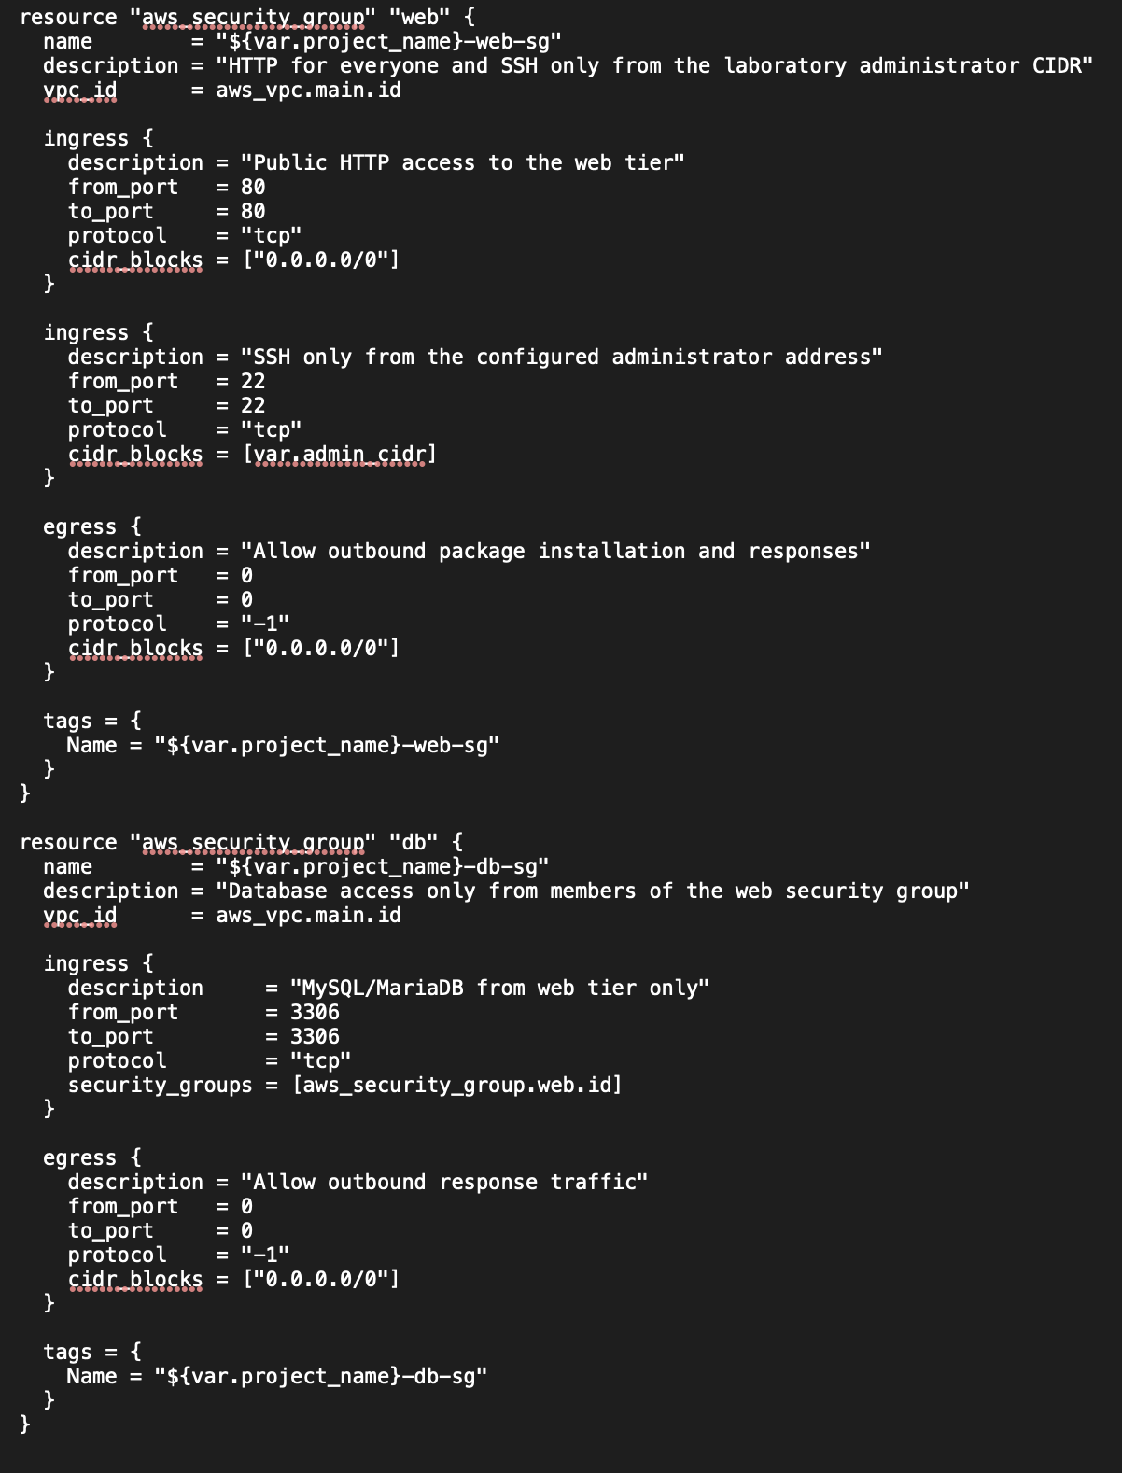

Step 6 — Create the web tier using count

{modules/compute/main.tf}

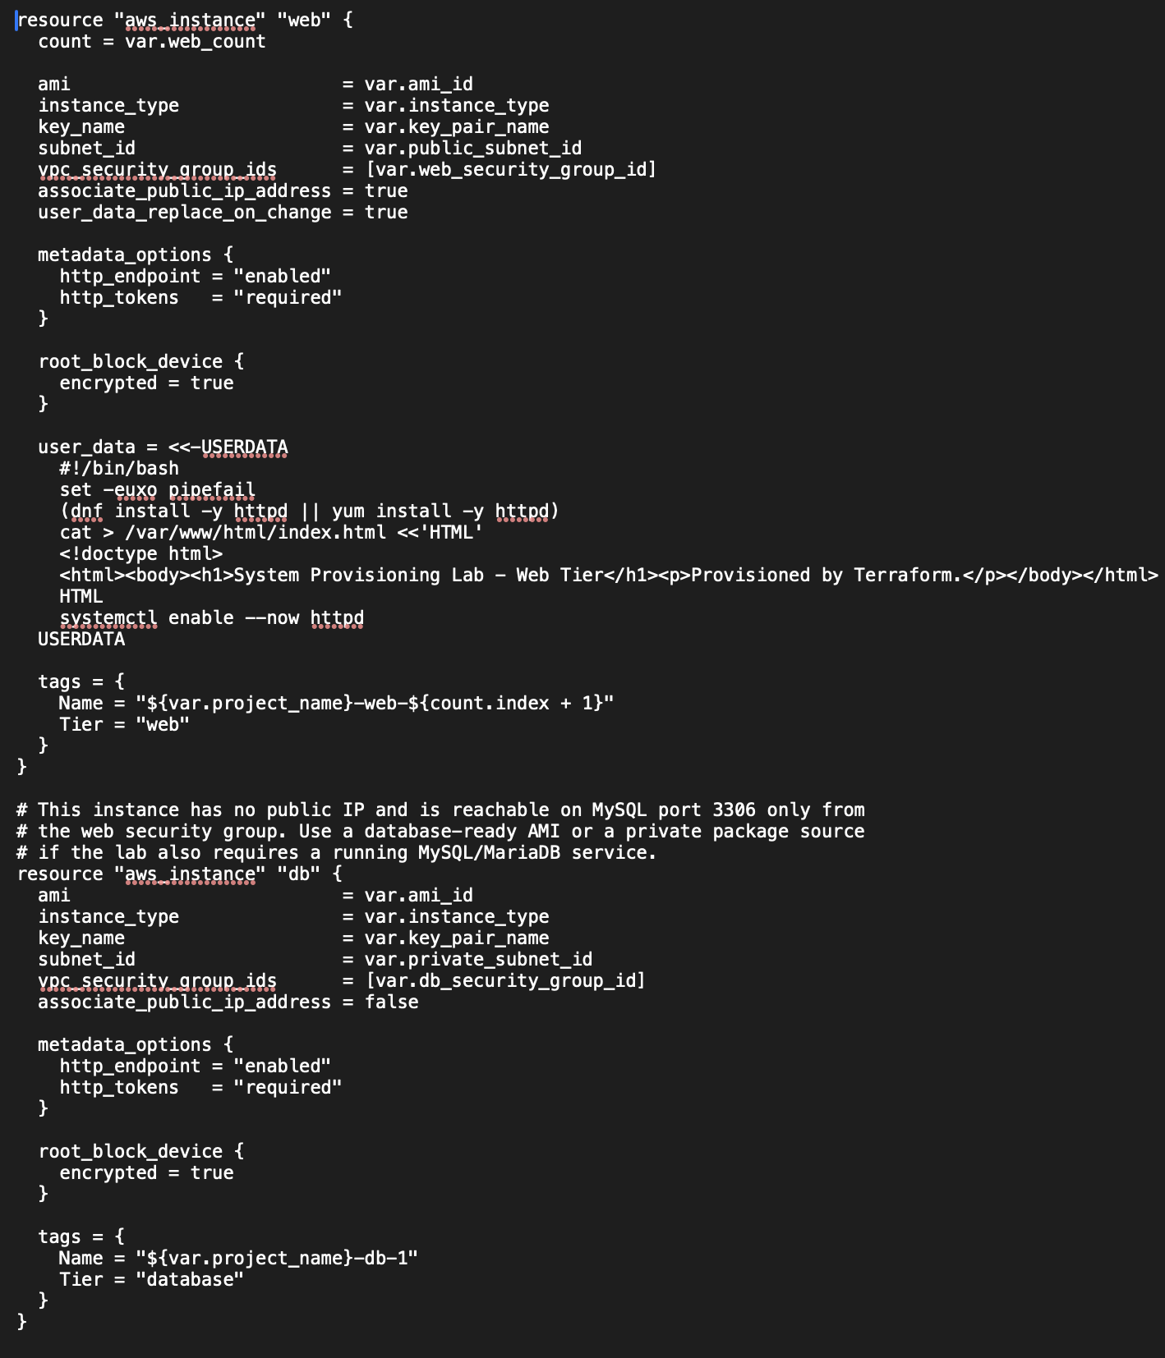

Step 7 — Create the dependent database instance

From {modules/compute/main.tf}

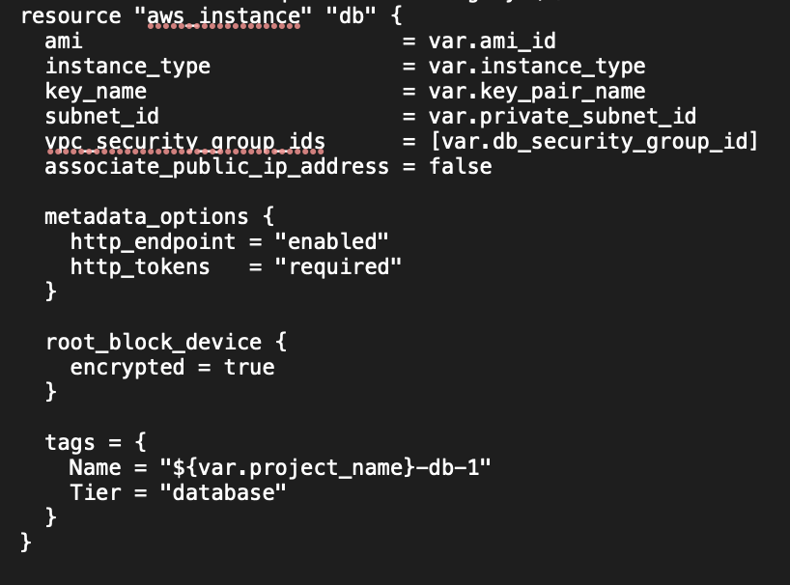

Step 8 — Wire the modules together in the root module
From{main.tf}
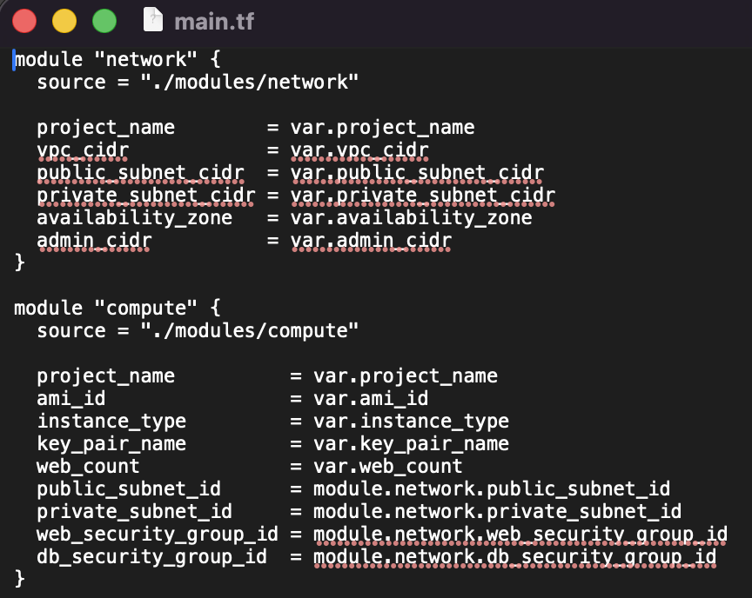

Step 9 — Inspect the dependency graph
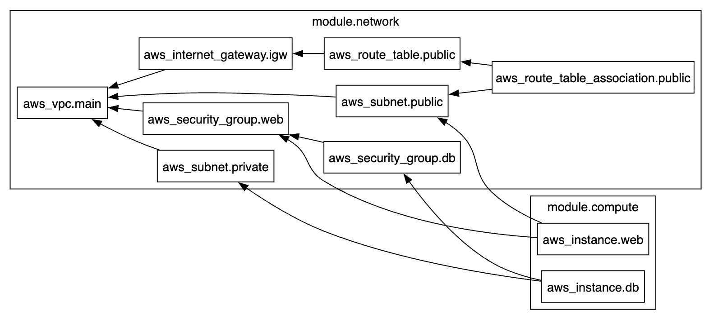
Step 10 — Plan and apply the complete stack
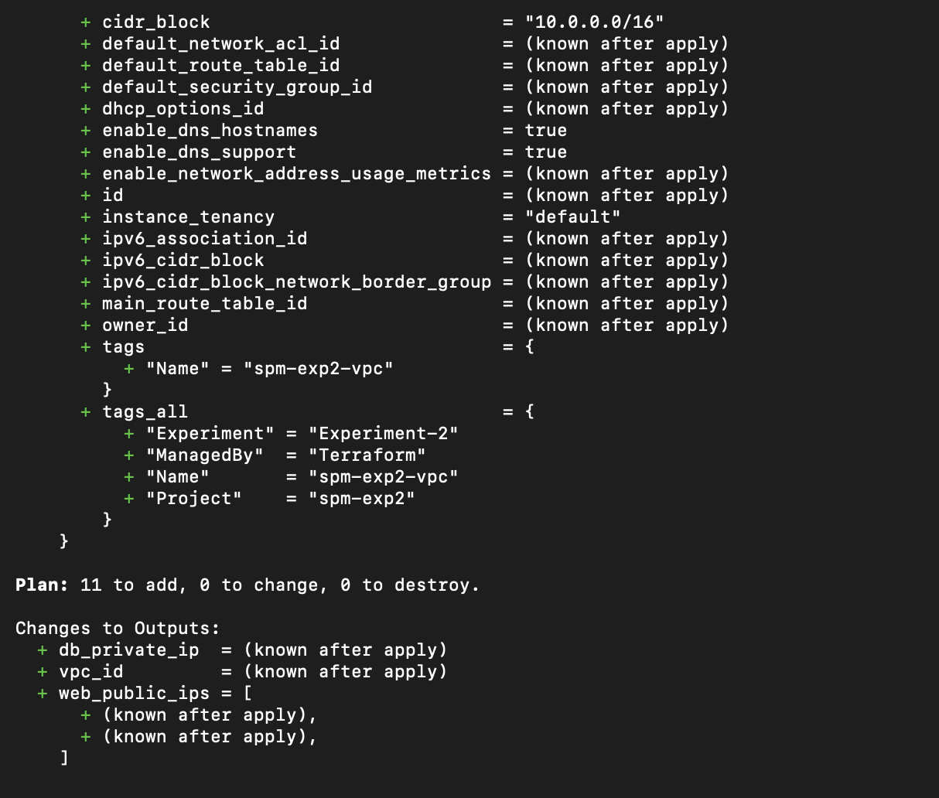

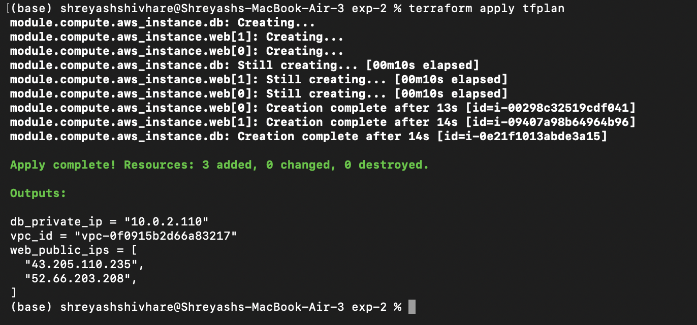
Step 11 — Execute the verification tests
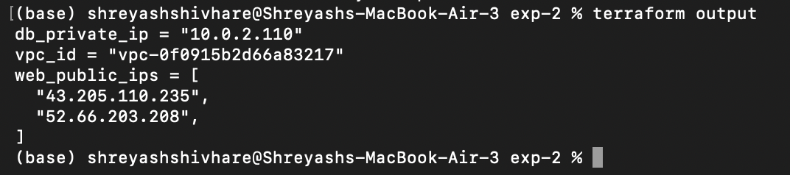
both web servers are reachable-
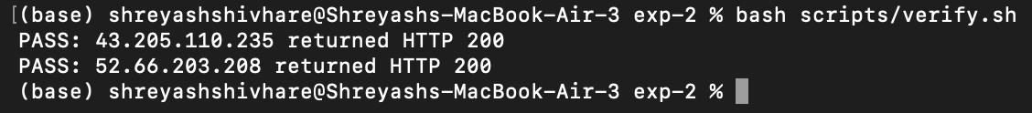
Database isolation-
Step 12 — Demonstrate reusability, then destroy
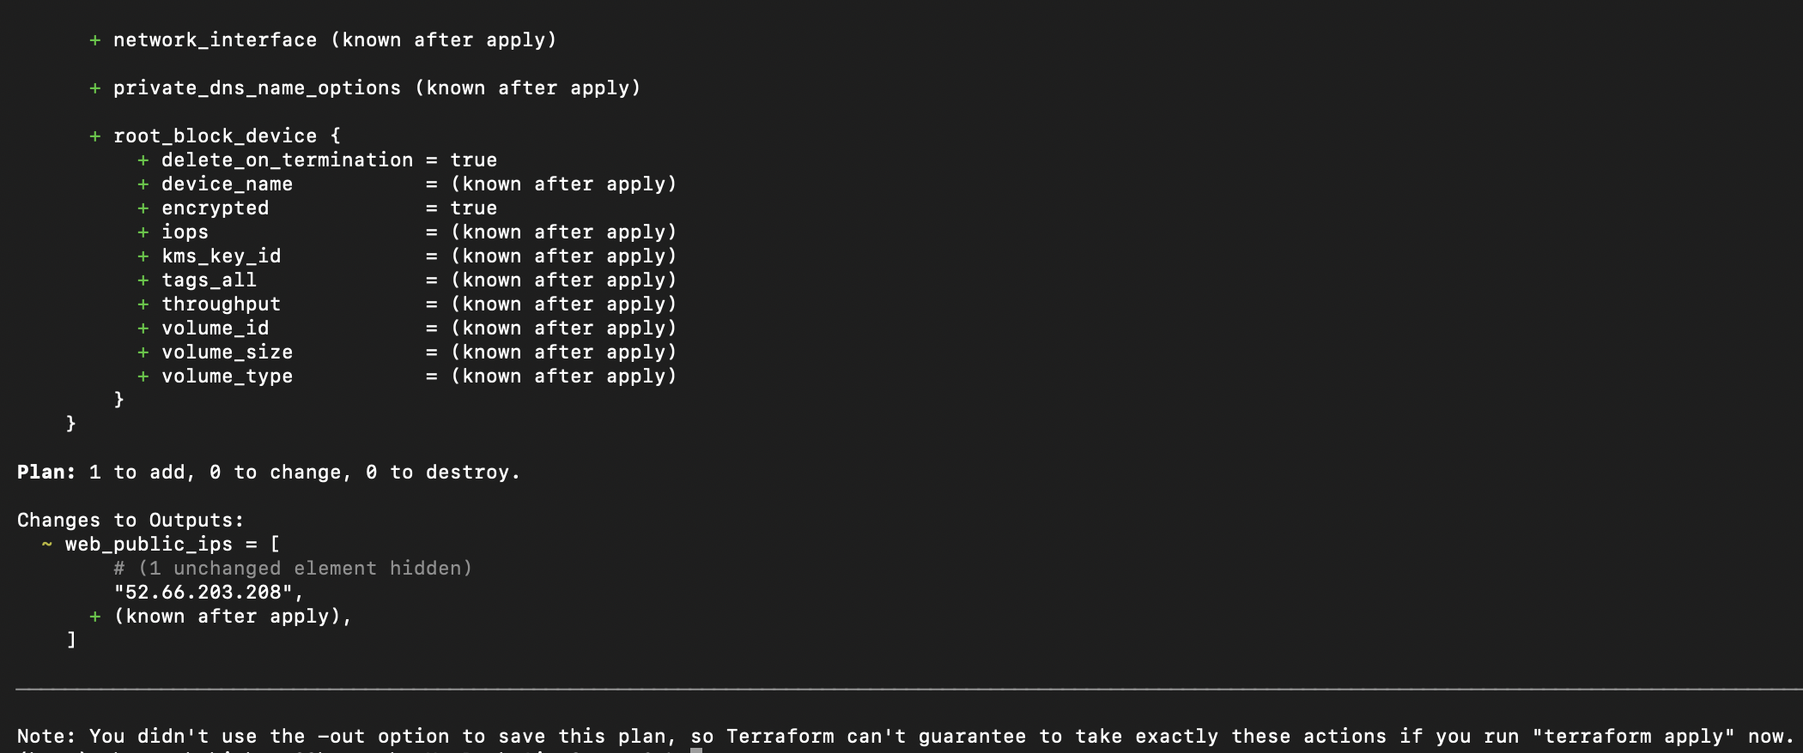

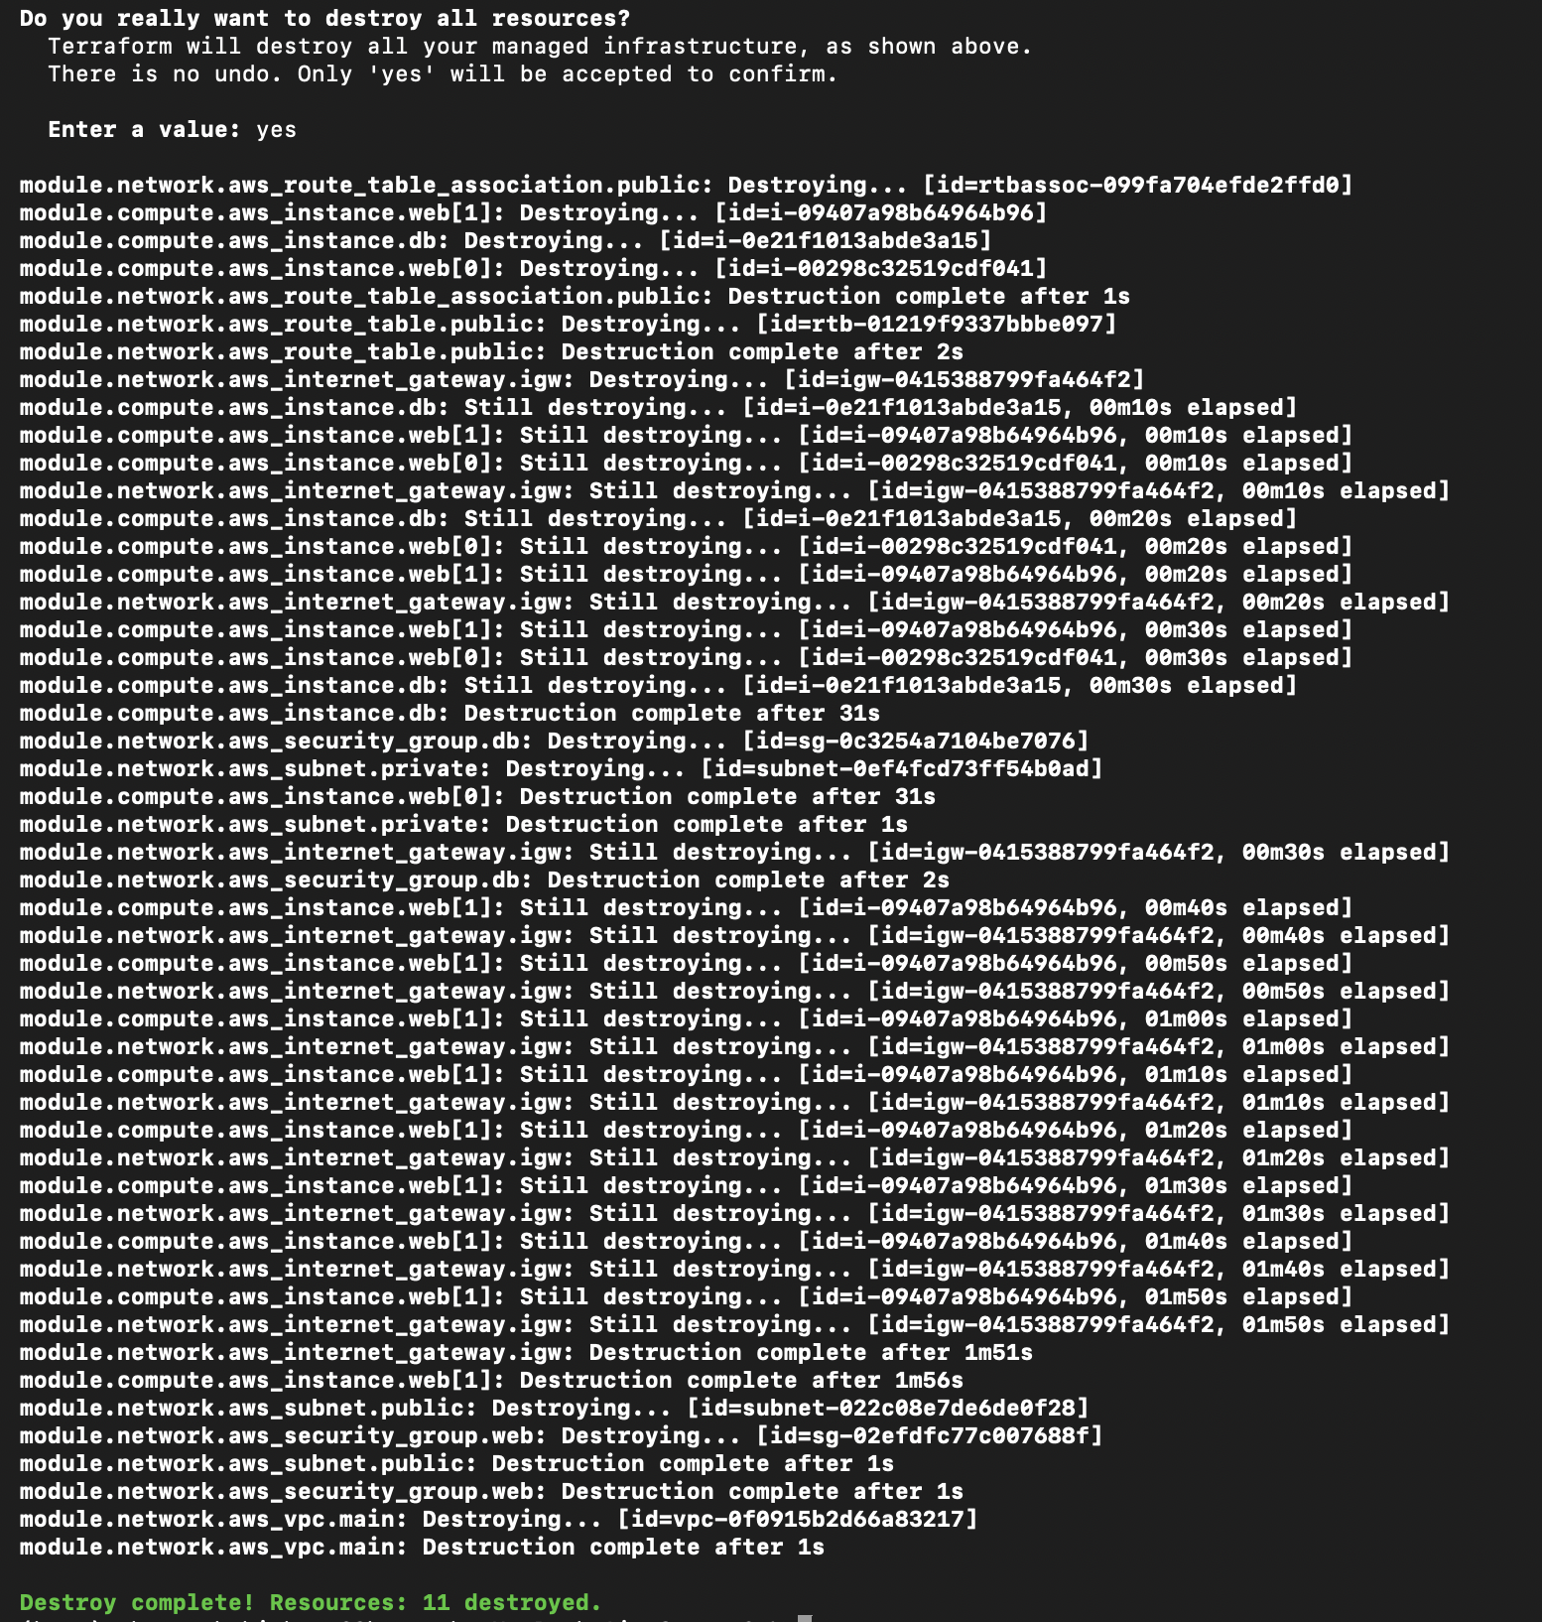

Program and Configuration Listings
Listing 2.1 — modules/network/main.tf (network objects) Listing 2.2 — modules/network/main.tf (security groups) Listing 2.3 — modules/compute/main.tf
Listing 2.4 — root main.tf and module wiring

Expected Output

Output 2.1 — apply log showing the creation order
Terraform will perform the following actions:

# module.compute.aws_instance.db will be created
+ resource "aws_instance" "db" {
+ ami = "ami-05a1f40ec1f9ea141"
+ arn = (known after apply)
+ associate_public_ip_address = false
+ availability_zone = (known after apply)
+ cpu_core_count = (known after apply)
+ cpu_threads_per_core = (known after apply)
+ disable_api_stop = (known after apply)
+ disable_api_termination = (known after apply)
+ ebs_optimized = (known after apply)
+ enable_primary_ipv6 = (known after apply)
+ get_password_data = false
+ host_id = (known after apply)
+ host_resource_group_arn = (known after apply)
+ iam_instance_profile = (known after apply)
+ id = (known after apply)
+ instance_initiated_shutdown_behavior = (known after apply)
+ instance_lifecycle = (known after apply)
+ instance_state = (known after apply)
+ instance_type = "t2.micro"
+ ipv6_address_count = (known after apply)
+ ipv6_addresses = (known after apply)
+ key_name = "spm-exp2-key"
+ monitoring = (known after apply)
+ outpost_arn = (known after apply)
+ password_data = (known after apply)
+ placement_group = (known after apply)
+ placement_partition_number = (known after apply)
+ primary_network_interface_id = (known after apply)
+ private_dns = (known after apply)
+ private_ip = (known after apply)
+ public_dns = (known after apply)
+ public_ip = (known after apply)
+ secondary_private_ips = (known after apply)
+ security_groups = (known after apply)
+ source_dest_check = true
+ spot_instance_request_id = (known after apply)
+ subnet_id = (known after apply)
+ tags = {
+ "Name" = "spm-exp2-db-1"
+ "Tier" = "database"
}
+ tags_all = {
+ "Experiment" = "Experiment-2"
+ "ManagedBy" = "Terraform"
+ "Name" = "spm-exp2-db-1"
+ "Project" = "spm-exp2"
+ "Tier" = "database"
}
+ tenancy = (known after apply)
+ user_data = (known after apply)
+ user_data_base64 = (known after apply)
+ user_data_replace_on_change = false
+ vpc_security_group_ids = (known after apply)

+ capacity_reservation_specification (known after apply)

+ cpu_options (known after apply)

+ ebs_block_device (known after apply)

+ enclave_options (known after apply)

+ ephemeral_block_device (known after apply)

+ instance_market_options (known after apply)

+ maintenance_options (known after apply)

+ metadata_options {
+ http_endpoint = "enabled"
+ http_protocol_ipv6 = "disabled"
+ http_put_response_hop_limit = (known after apply)
+ http_tokens = "required"
+ instance_metadata_tags = (known after apply)
}

+ network_interface (known after apply)

+ private_dns_name_options (known after apply)

+ root_block_device {
+ delete_on_termination = true
+ device_name = (known after apply)
+ encrypted = true
+ iops = (known after apply)
+ kms_key_id = (known after apply)
+ tags_all = (known after apply)
+ throughput = (known after apply)
+ volume_id = (known after apply)
+ volume_size = (known after apply)
+ volume_type = (known after apply)
}
}

# module.compute.aws_instance.web[0] will be created
+ resource "aws_instance" "web" {
+ ami = "ami-05a1f40ec1f9ea141"
+ arn = (known after apply)
+ associate_public_ip_address = true
+ availability_zone = (known after apply)
+ cpu_core_count = (known after apply)
+ cpu_threads_per_core = (known after apply)
+ disable_api_stop = (known after apply)
+ disable_api_termination = (known after apply)
+ ebs_optimized = (known after apply)
+ enable_primary_ipv6 = (known after apply)
+ get_password_data = false
+ host_id = (known after apply)
+ host_resource_group_arn = (known after apply)
+ iam_instance_profile = (known after apply)
+ id = (known after apply)
+ instance_initiated_shutdown_behavior = (known after apply)
+ instance_lifecycle = (known after apply)
+ instance_state = (known after apply)
+ instance_type = "t2.micro"
+ ipv6_address_count = (known after apply)
+ ipv6_addresses = (known after apply)
+ key_name = "spm-exp2-key"
+ monitoring = (known after apply)
+ outpost_arn = (known after apply)
+ password_data = (known after apply)
+ placement_group = (known after apply)
+ placement_partition_number = (known after apply)
+ primary_network_interface_id = (known after apply)
+ private_dns = (known after apply)
+ private_ip = (known after apply)
+ public_dns = (known after apply)
+ public_ip = (known after apply)
+ secondary_private_ips = (known after apply)
+ security_groups = (known after apply)
+ source_dest_check = true
+ spot_instance_request_id = (known after apply)
+ subnet_id = (known after apply)
+ tags = {
+ "Name" = "spm-exp2-web-1"
+ "Tier" = "web"
}
+ tags_all = {
+ "Experiment" = "Experiment-2"
+ "ManagedBy" = "Terraform"
+ "Name" = "spm-exp2-web-1"
+ "Project" = "spm-exp2"
+ "Tier" = "web"
}
+ tenancy = (known after apply)
+ user_data = "758d1e494b387386477e7eb83d20eacfd8f42ae1"
+ user_data_base64 = (known after apply)
+ user_data_replace_on_change = true
+ vpc_security_group_ids = (known after apply)

+ capacity_reservation_specification (known after apply)

+ cpu_options (known after apply)

+ ebs_block_device (known after apply)

+ enclave_options (known after apply)

+ ephemeral_block_device (known after apply)

+ instance_market_options (known after apply)

+ maintenance_options (known after apply)

+ metadata_options {
+ http_endpoint = "enabled"
+ http_protocol_ipv6 = "disabled"
+ http_put_response_hop_limit = (known after apply)
+ http_tokens = "required"
+ instance_metadata_tags = (known after apply)
}

+ network_interface (known after apply)

+ private_dns_name_options (known after apply)

+ root_block_device {
+ delete_on_termination = true
+ device_name = (known after apply)
+ encrypted = true
+ iops = (known after apply)
+ kms_key_id = (known after apply)
+ tags_all = (known after apply)
+ throughput = (known after apply)
+ volume_id = (known after apply)
+ volume_size = (known after apply)
+ volume_type = (known after apply)
}
}

# module.compute.aws_instance.web[1] will be created
+ resource "aws_instance" "web" {
+ ami = "ami-05a1f40ec1f9ea141"
+ arn = (known after apply)
+ associate_public_ip_address = true
+ availability_zone = (known after apply)
+ cpu_core_count = (known after apply)
+ cpu_threads_per_core = (known after apply)
+ disable_api_stop = (known after apply)
+ disable_api_termination = (known after apply)
+ ebs_optimized = (known after apply)
+ enable_primary_ipv6 = (known after apply)
+ get_password_data = false
+ host_id = (known after apply)
+ host_resource_group_arn = (known after apply)
+ iam_instance_profile = (known after apply)
+ id = (known after apply)
+ instance_initiated_shutdown_behavior = (known after apply)
+ instance_lifecycle = (known after apply)
+ instance_state = (known after apply)
+ instance_type = "t2.micro"
+ ipv6_address_count = (known after apply)
+ ipv6_addresses = (known after apply)
+ key_name = "spm-exp2-key"
+ monitoring = (known after apply)
+ outpost_arn = (known after apply)
+ password_data = (known after apply)
+ placement_group = (known after apply)
+ placement_partition_number = (known after apply)
+ primary_network_interface_id = (known after apply)
+ private_dns = (known after apply)
+ private_ip = (known after apply)
+ public_dns = (known after apply)
+ public_ip = (known after apply)
+ secondary_private_ips = (known after apply)
+ security_groups = (known after apply)
+ source_dest_check = true
+ spot_instance_request_id = (known after apply)
+ subnet_id = (known after apply)
+ tags = {
+ "Name" = "spm-exp2-web-2"
+ "Tier" = "web"
}
+ tags_all = {
+ "Experiment" = "Experiment-2"
+ "ManagedBy" = "Terraform"
+ "Name" = "spm-exp2-web-2"
+ "Project" = "spm-exp2"
+ "Tier" = "web"
}
+ tenancy = (known after apply)
+ user_data = "758d1e494b387386477e7eb83d20eacfd8f42ae1"
+ user_data_base64 = (known after apply)
+ user_data_replace_on_change = true
+ vpc_security_group_ids = (known after apply)

+ capacity_reservation_specification (known after apply)

+ cpu_options (known after apply)

+ ebs_block_device (known after apply)

+ enclave_options (known after apply)

+ ephemeral_block_device (known after apply)

+ instance_market_options (known after apply)

+ maintenance_options (known after apply)

+ metadata_options {
+ http_endpoint = "enabled"
+ http_protocol_ipv6 = "disabled"
+ http_put_response_hop_limit = (known after apply)
+ http_tokens = "required"
+ instance_metadata_tags = (known after apply)
}

+ network_interface (known after apply)

+ private_dns_name_options (known after apply)

+ root_block_device {
+ delete_on_termination = true
+ device_name = (known after apply)
+ encrypted = true
+ iops = (known after apply)
+ kms_key_id = (known after apply)
+ tags_all = (known after apply)
+ throughput = (known after apply)
+ volume_id = (known after apply)
+ volume_size = (known after apply)
+ volume_type = (known after apply)
}
}

# module.network.aws_internet_gateway.igw will be created
+ resource "aws_internet_gateway" "igw" {
+ arn = (known after apply)
+ id = (known after apply)
+ owner_id = (known after apply)
+ tags = {
+ "Name" = "spm-exp2-igw"
}
+ tags_all = {
+ "Experiment" = "Experiment-2"
+ "ManagedBy" = "Terraform"
+ "Name" = "spm-exp2-igw"
+ "Project" = "spm-exp2"
}
+ vpc_id = (known after apply)
}

# module.network.aws_route_table.public will be created
+ resource "aws_route_table" "public" {
+ arn = (known after apply)
+ id = (known after apply)
+ owner_id = (known after apply)
+ propagating_vgws = (known after apply)
+ route = [
+ {
+ cidr_block = "0.0.0.0/0"
+ gateway_id = (known after apply)
# (11 unchanged attributes hidden)
},
]
+ tags = {
+ "Name" = "spm-exp2-public-rt"
}
+ tags_all = {
+ "Experiment" = "Experiment-2"
+ "ManagedBy" = "Terraform"
+ "Name" = "spm-exp2-public-rt"
+ "Project" = "spm-exp2"
}
+ vpc_id = (known after apply)
}

# module.network.aws_route_table_association.public will be created
+ resource "aws_route_table_association" "public" {
+ id = (known after apply)
+ route_table_id = (known after apply)
+ subnet_id = (known after apply)
}

# module.network.aws_security_group.db will be created
+ resource "aws_security_group" "db" {
+ arn = (known after apply)
+ description = "Database access only from members of the web security group"
+ egress = [
+ {
+ cidr_blocks = [
+ "0.0.0.0/0",
]
+ description = "Allow outbound response traffic"
+ from_port = 0
+ ipv6_cidr_blocks = []
+ prefix_list_ids = []
+ protocol = "-1"
+ security_groups = []
+ self = false
+ to_port = 0
},
]
+ id = (known after apply)
+ ingress = [
+ {
+ cidr_blocks = []
+ description = "MySQL/MariaDB from web tier only"
+ from_port = 3306
+ ipv6_cidr_blocks = []
+ prefix_list_ids = []
+ protocol = "tcp"
+ security_groups = (known after apply)
+ self = false
+ to_port = 3306
},
]
+ name = "spm-exp2-db-sg"
+ name_prefix = (known after apply)
+ owner_id = (known after apply)
+ revoke_rules_on_delete = false
+ tags = {
+ "Name" = "spm-exp2-db-sg"
}
+ tags_all = {
+ "Experiment" = "Experiment-2"
+ "ManagedBy" = "Terraform"
+ "Name" = "spm-exp2-db-sg"
+ "Project" = "spm-exp2"
}
+ vpc_id = (known after apply)
}

# module.network.aws_security_group.web will be created
+ resource "aws_security_group" "web" {
+ arn = (known after apply)
+ description = "HTTP for everyone and SSH only from the laboratory administrator CIDR"
+ egress = [
+ {
+ cidr_blocks = [
+ "0.0.0.0/0",
]
+ description = "Allow outbound package installation and responses"
+ from_port = 0
+ ipv6_cidr_blocks = []
+ prefix_list_ids = []
+ protocol = "-1"
+ security_groups = []
+ self = false
+ to_port = 0
},
]
+ id = (known after apply)
+ ingress = [
+ {
+ cidr_blocks = [
+ "0.0.0.0/0",
]
+ description = "Public HTTP access to the web tier"
+ from_port = 80
+ ipv6_cidr_blocks = []
+ prefix_list_ids = []
+ protocol = "tcp"
+ security_groups = []
+ self = false
+ to_port = 80
},
+ {
+ cidr_blocks = [
+ "103.212.138.244/32",
]
+ description = "SSH only from the configured administrator address"
+ from_port = 22
+ ipv6_cidr_blocks = []
+ prefix_list_ids = []
+ protocol = "tcp"
+ security_groups = []
+ self = false
+ to_port = 22
},
]
+ name = "spm-exp2-web-sg"
+ name_prefix = (known after apply)
+ owner_id = (known after apply)
+ revoke_rules_on_delete = false
+ tags = {
+ "Name" = "spm-exp2-web-sg"
}
+ tags_all = {
+ "Experiment" = "Experiment-2"
+ "ManagedBy" = "Terraform"
+ "Name" = "spm-exp2-web-sg"
+ "Project" = "spm-exp2"
}
+ vpc_id = (known after apply)
}

# module.network.aws_subnet.private will be created
+ resource "aws_subnet" "private" {
+ arn = (known after apply)
+ assign_ipv6_address_on_creation = false
+ availability_zone = "ap-south-1a"
+ availability_zone_id = (known after apply)
+ cidr_block = "10.0.2.0/24"
+ enable_dns64 = false
+ enable_resource_name_dns_a_record_on_launch = false
+ enable_resource_name_dns_aaaa_record_on_launch = false
+ id = (known after apply)
+ ipv6_cidr_block_association_id = (known after apply)
+ ipv6_native = false
+ map_public_ip_on_launch = false
+ owner_id = (known after apply)
+ private_dns_hostname_type_on_launch = (known after apply)
+ tags = {
+ "Name" = "spm-exp2-private-db"
+ "Tier" = "database"
}
+ tags_all = {
+ "Experiment" = "Experiment-2"
+ "ManagedBy" = "Terraform"
+ "Name" = "spm-exp2-private-db"
+ "Project" = "spm-exp2"
+ "Tier" = "database"
}
+ vpc_id = (known after apply)
}

# module.network.aws_subnet.public will be created
+ resource "aws_subnet" "public" {
+ arn = (known after apply)
+ assign_ipv6_address_on_creation = false
+ availability_zone = "ap-south-1a"
+ availability_zone_id = (known after apply)
+ cidr_block = "10.0.1.0/24"
+ enable_dns64 = false
+ enable_resource_name_dns_a_record_on_launch = false
+ enable_resource_name_dns_aaaa_record_on_launch = false
+ id = (known after apply)
+ ipv6_cidr_block_association_id = (known after apply)
+ ipv6_native = false
+ map_public_ip_on_launch = true
+ owner_id = (known after apply)
+ private_dns_hostname_type_on_launch = (known after apply)
+ tags = {
+ "Name" = "spm-exp2-public-web"
+ "Tier" = "web"
}
+ tags_all = {
+ "Experiment" = "Experiment-2"
+ "ManagedBy" = "Terraform"
+ "Name" = "spm-exp2-public-web"
+ "Project" = "spm-exp2"
+ "Tier" = "web"
}
+ vpc_id = (known after apply)
}

# module.network.aws_vpc.main will be created
+ resource "aws_vpc" "main" {
+ arn = (known after apply)
+ cidr_block = "10.0.0.0/16"
+ default_network_acl_id = (known after apply)
+ default_route_table_id = (known after apply)
+ default_security_group_id = (known after apply)
+ dhcp_options_id = (known after apply)
+ enable_dns_hostnames = true
+ enable_dns_support = true
+ enable_network_address_usage_metrics = (known after apply)
+ id = (known after apply)
+ instance_tenancy = "default"
+ ipv6_association_id = (known after apply)
+ ipv6_cidr_block = (known after apply)
+ ipv6_cidr_block_network_border_group = (known after apply)
+ main_route_table_id = (known after apply)
+ owner_id = (known after apply)
+ tags = {
+ "Name" = "spm-exp2-vpc"
}
+ tags_all = {
+ "Experiment" = "Experiment-2"
+ "ManagedBy" = "Terraform"
+ "Name" = "spm-exp2-vpc"
+ "Project" = "spm-exp2"
}
}

Plan: 11 to add, 0 to change, 0 to destroy.

Changes to Outputs:
+ db_private_ip = (known after apply)
+ vpc_id = (known after apply)
+ web_public_ips = [
+ (known after apply),
+ (known after apply),
]

Outputs:

db_private_ip = "10.0.2.110"
vpc_id = "vpc-0f0915b2d66a83217"
web_public_ips = [
"43.205.110.235",
"52.66.203.208",
]

Output 2.2 — scaling test after changing web_count to 3
(base) shreyashshivhare@Shreyashs-MacBook-Air-3 exp-2 % terraform plan -var='web_count=3'
var.admin_cidr
Your current public IPv4 address in CIDR notation. Only this range may SSH to the web tier.

Enter a value: 103.212.138.244/32

var.ami_id
AMI ID for an Amazon Linux web/database instance in aws_region.

Enter a value: ami-05a1f40ec1f9ea141

var.key_pair_name
Existing EC2 key-pair name in aws_region. The private .pem file is never stored in Terraform.

Enter a value: spm-exp2-key

module.network.aws_vpc.main: Refreshing state... [id=vpc-0f0915b2d66a83217]
module.network.aws_internet_gateway.igw: Refreshing state... [id=igw-0415388799fa464f2]
module.network.aws_subnet.private: Refreshing state... [id=subnet-0ef4fcd73ff54b0ad]
module.network.aws_subnet.public: Refreshing state... [id=subnet-022c08e7de6de0f28]
module.network.aws_security_group.web: Refreshing state... [id=sg-02efdfc77c007688f]
module.network.aws_route_table.public: Refreshing state... [id=rtb-01219f9337bbbe097]
module.network.aws_route_table_association.public: Refreshing state... [id=rtbassoc-099fa704efde2ffd0]
module.network.aws_security_group.db: Refreshing state... [id=sg-0c3254a7104be7076]
module.compute.aws_instance.web[1]: Refreshing state... [id=i-09407a98b64964b96]
module.compute.aws_instance.web[0]: Refreshing state... [id=i-00298c32519cdf041]
module.compute.aws_instance.db: Refreshing state... [id=i-0e21f1013abde3a15]

Terraform used the selected providers to generate the following execution plan. Resource actions are indicated

Plan: 1 to add, 0 to change, 0 to destroy.

Changes to Outputs:
~ web_public_ips = [
# (1 unchanged element hidden)
"52.66.203.208",
+ (known after apply),
]

My Experiment Output

Observation Table
Complete this table with the values observed during your own session.

Test | Method | Expected | Observed
Creation order |  | Network before compute | VPC was created first, followed by subnets, internet gateway, route table, and security groups; web and DB instances were created afterward.
Web reachability |  | HTTP 200 from both | 43.205.110.235 returned HTTP 200 and 52.66.203.208 returned HTTP 200.
SSH restriction |  | Connection times out | Timed out after 10s
Database isolation |  | Refused or timed out | ssh: connect to host 43.205.110.235 port 22: Operation timed out
Tier-to-tier access |  | Connection succeeds | The current DB VM has no MariaDB/MySQL service running, so the port test cannot prove an application connection.
Reusability |  | 1 to add, 0 to change | Plan: 1 to add, 0 to change, 0 to destroy.
Teardown order |  | Instances before subnets | Web and DB instances were removed before security groups, subnets, route table, gateway, and VPC.

Result
A two-tier network topology consisting of a VPC, a public and a private subnet, an internet gateway, routing and two security groups, together with three interdependent virtual machines, …

Precautions
    - Set the admin CIDR to the laboratory's actual public address. Leaving SSH open to 0.0.0.0/0 will cause the configuration to be rejected during evaluation and exposes the instance to automated attacks within minutes.
    - Place the database in the private subnet. An instance in a public subnet with a restrictive security group is still one misconfiguration away from exposure.
    - Do not embed the key pair file or its contents in the configuration; reference the key by name only.
    - Verify that every subnet CIDR lies within the VPC CIDR and that the two subnets do not overlap.

Theory-

